**WEEKLY REPORT 3**

This week, I worked on researching and gathering requirements for the design of our clinic registration process.

I also reviewed the HIPAA and IMS regulations to ensure that our design complies with these standards.

The Health Insurance Portability and Accountability Act (HIPAA) lays out three rules for protecting patient health information, namely:

* The Privacy Rule.
* The Security Rule.
* The Breach Notification Rule.

The goal is to create a seamless registration process that is easy for patients to navigate and provides all necessary information to the healthcare provider.

NEXT WEEK: Make a wireframe of the welcome screen and research about that.

<https://medspecialized.lmcenter.net/course/63200e53a49e2738ec9d756f/module/5e574bc23b4e1125905e3edb>

**WEEKLY REPORT 4**

This week, I focused on designing the wireframe and UI of the welcome screen for our healthcare application.

The goal was to create a visually appealing and welcoming screen that provides important information to the patient, such as clinic hours, contact information, and links to important resources.

I also worked on ensuring that the screen complies with HIPAA and IMS standards.

NEXT WEEK: Make a wireframe of the check in screen and research about that.

<https://4iili5.axshare.com/#id=r9d8xy&g=14&p=welcome_screen_3>

<https://dribbble.com/tags/welcome_screen>

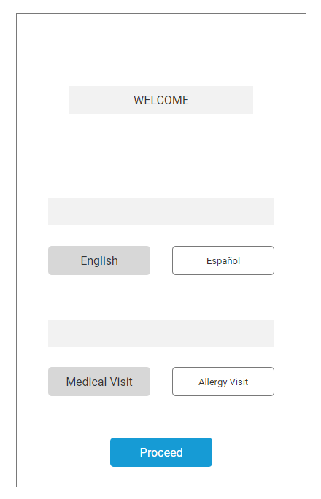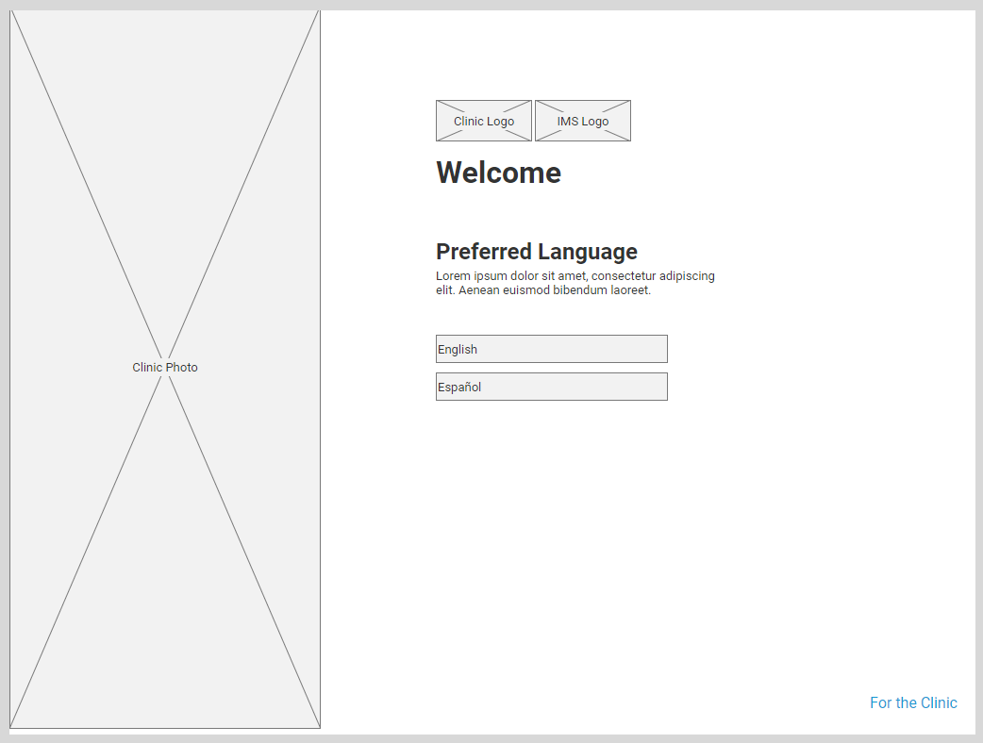

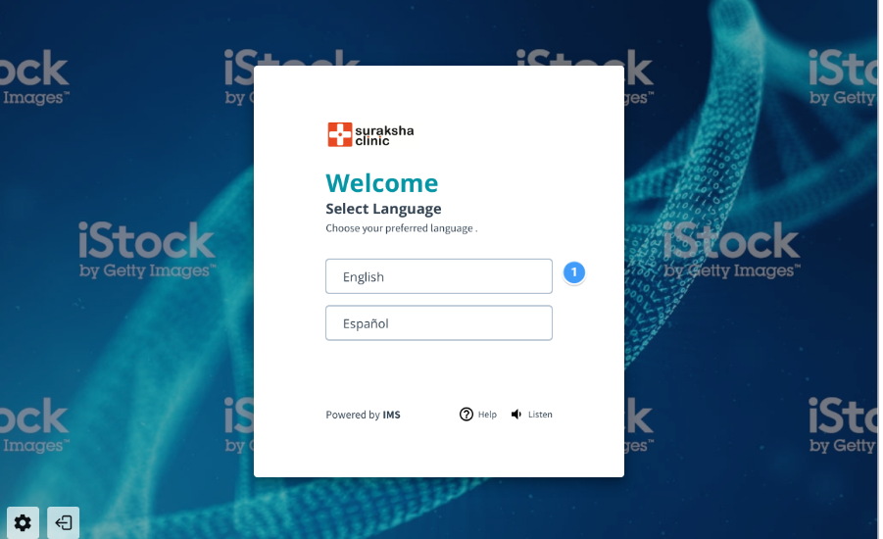

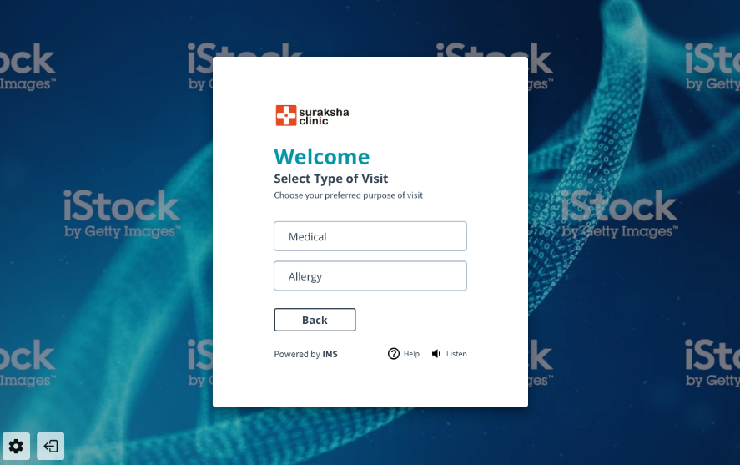

**WEEKLY REPORT 5**

This week, I worked on designing the wireframe and UI of the check-in process for our healthcare application.

The goal was to create a process that is easy for patients to complete, while also providing all necessary information to the healthcare provider.

I also looked into IMS and HIPAA rules to make sure our design conforms to these standards.

NEXT WEEK: Make a more design of the check in screen and review from the team.

<https://dribbble.com/search/check-in-screen-for-web>

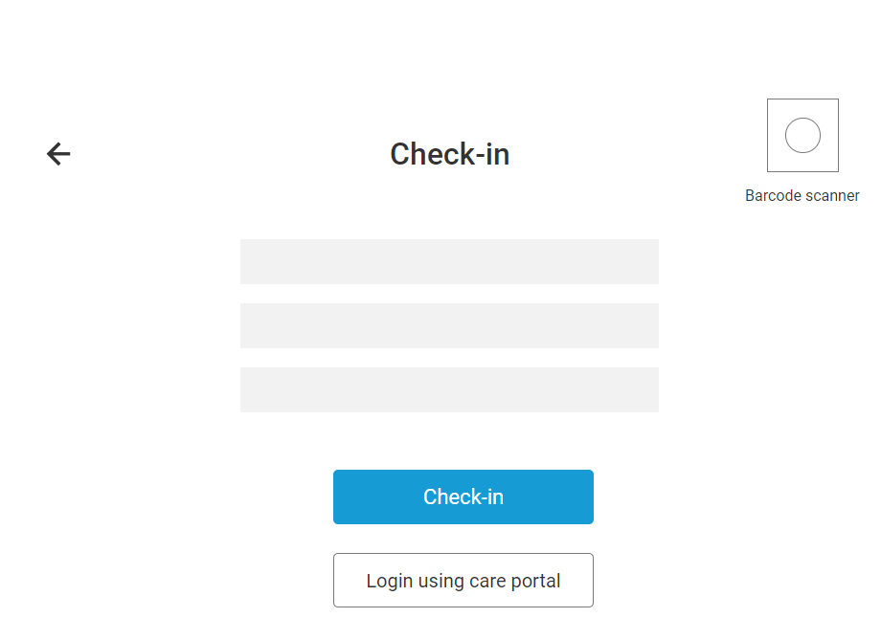

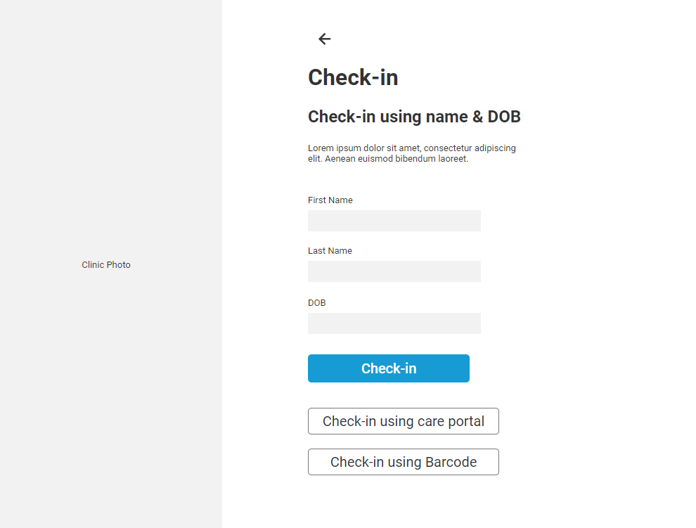

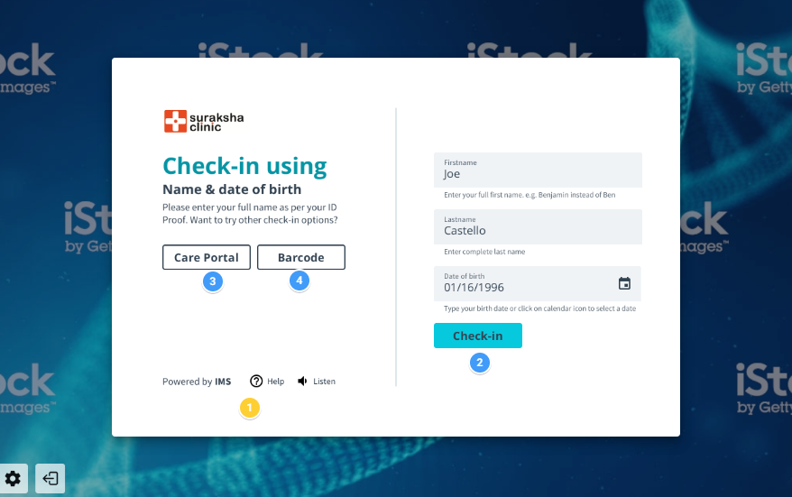

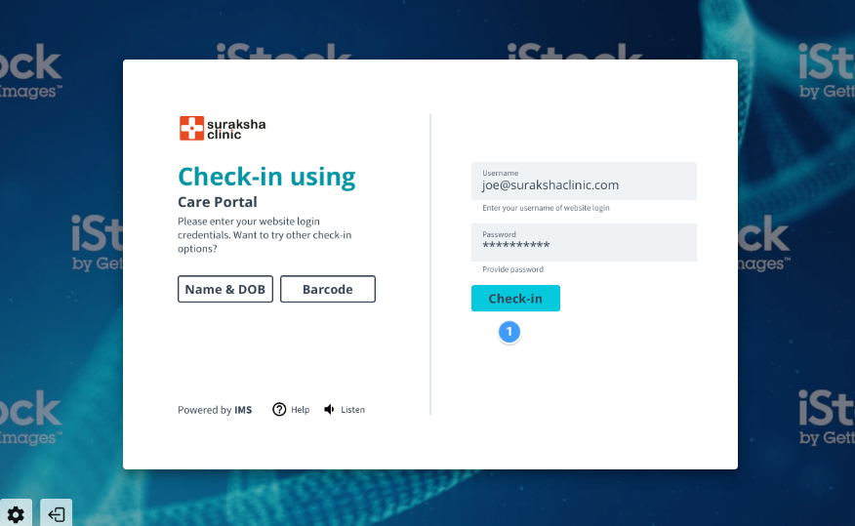

**WEEKLY REPORT 6**

This week, I worked on designing the UI of the check-in process for our healthcare application.

The goal was to create a process that is easy for patients to complete, while also providing all necessary information to the healthcare provider.

I also looked into IMS and HIPAA rules to make sure our design conforms to these standards.

NEXT WEEK: Make a more design of login and sign up screen and research about that.

<https://dribbble.com/search/check-in-screen-for-web>

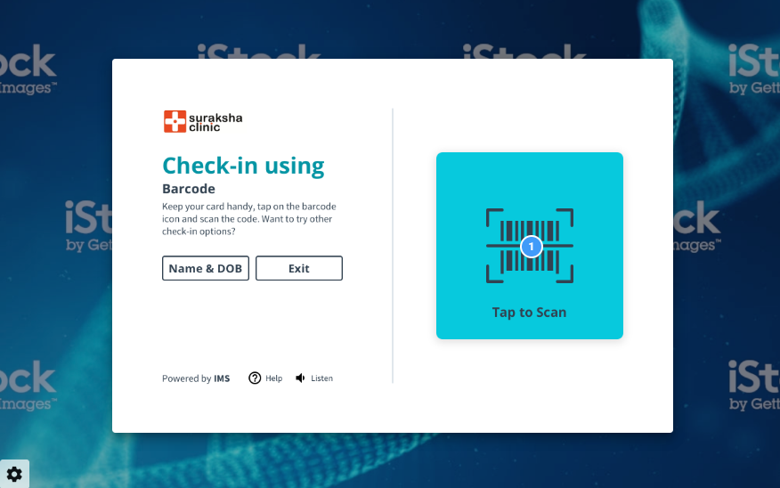

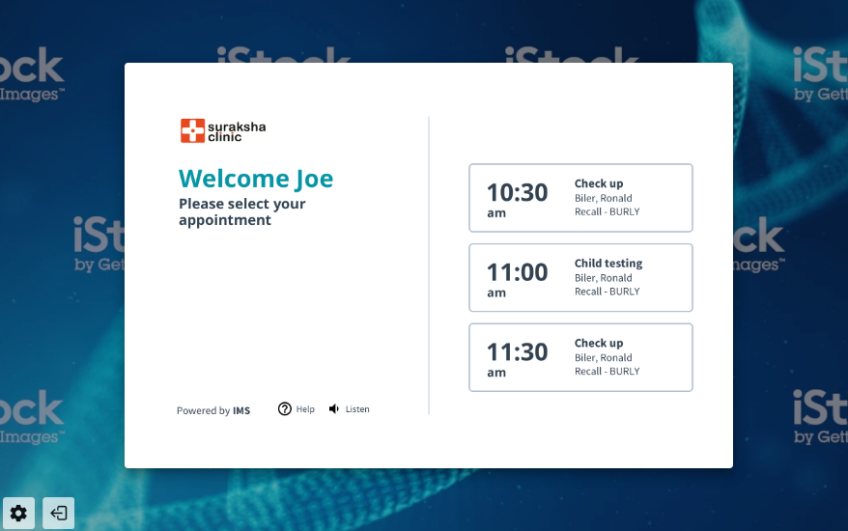

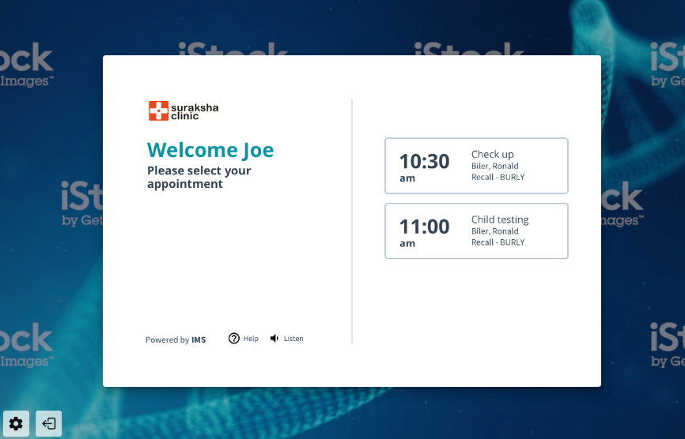

**WEEKLY REPORT 7**

This week, I worked on designing the UI of the Register screen for our healthcare application.

The goal was to create a process that is easy for patients to complete, while also providing all necessary information to the healthcare provider.

I also looked into IMS and HIPAA rules to make sure our design conforms to these standards.

NEXT WEEK: Make a more login design of login and sign up screen.

<https://dribbble.com/search/login-screen>

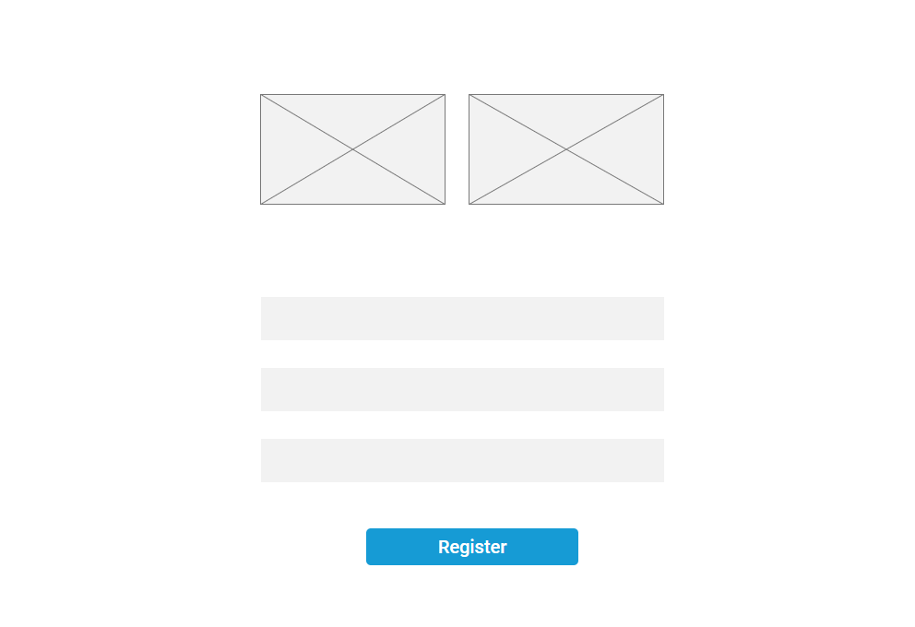

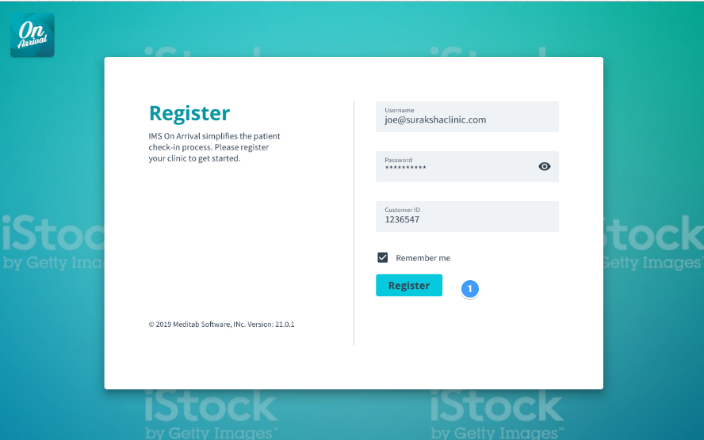

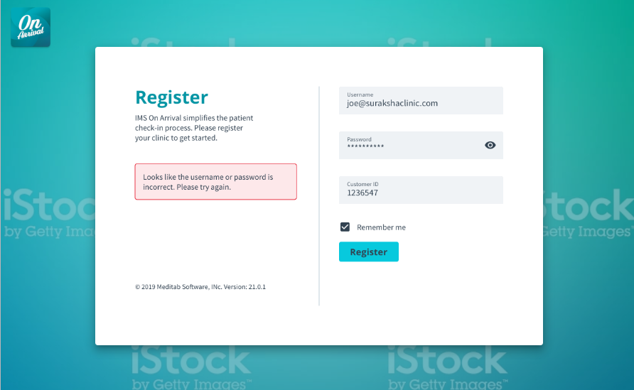

**WEEKLY REPORT 8**

This week, I worked on designing the UI of the Login screen for our healthcare application.

The goal was to create a process that is easy for patients to complete, while also providing all necessary information to the healthcare provider.

I also looked into IMS and HIPAA rules to make sure our design conforms to these standards.

NEXT WEEK: Make a login office and patient details screen for login method.

<https://dribbble.com/search/login-screen>

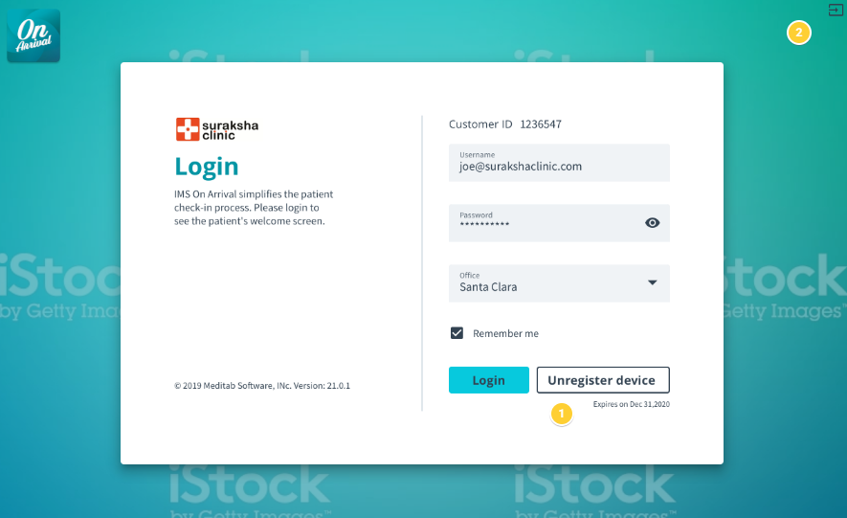

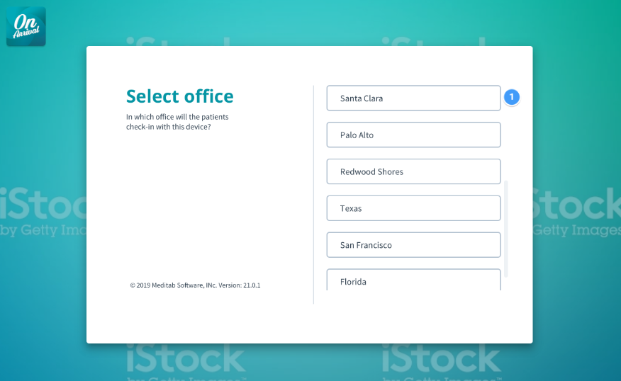

**WEEKLY REPORT 9**

This week, I worked on designing the UI of the Patient Login screen for our healthcare application.

The goal was to create a user-friendly interface that allows patients to enter and update their personal and medical information easily.

I also looked into IMS and HIPAA rules to make sure our design conforms to these standards.

NEXT WEEK: Make a login office and patient details screen for login method.

<https://dribbble.com/search/login-screen>

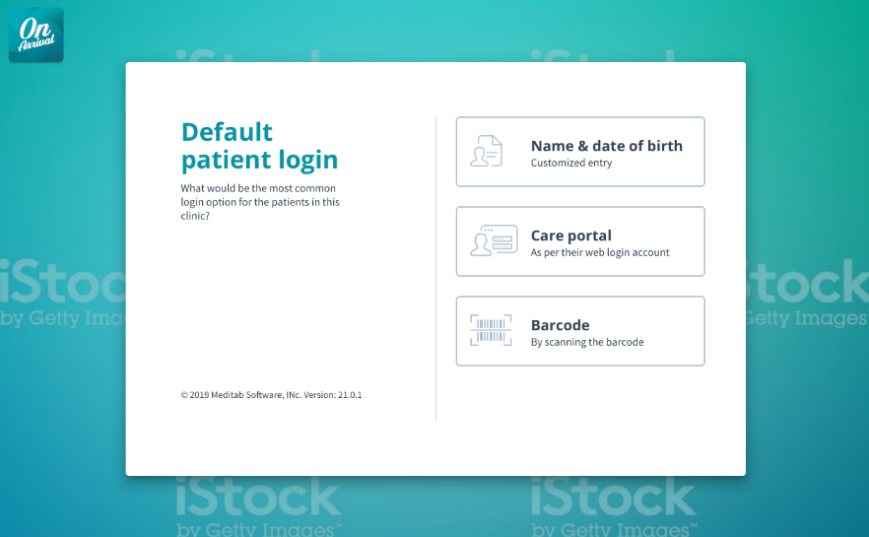

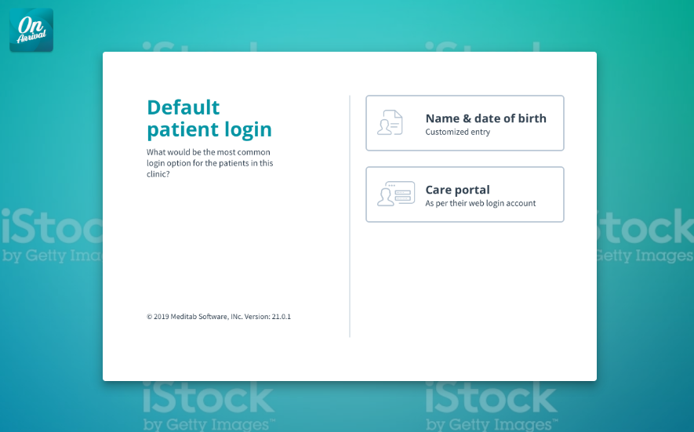

**WEEKLY REPORT 10**

This week, I learned how to make a design document so that developers can easily understand and work on that via coding.

The goal was to learn better user experience for creating design and also design documents for that.

So I learned to design documents to outline the design decisions and standards for a project. The document serves as a guide for the design team and provides a clear understanding of the project's design requirements.

The designer starts by conducting research, defining the design goals, and creating user personas and a user journey map.

Wireframes and mockups are then created, followed by design specifications and prototyping to test the design and functionality.

Finally, a final design document is created that includes all the design elements, specifications, wireframes, mockups, and prototypes, as well as the design decisions and rationale behind the design choices.

I also looked into IMS and HIPAA rules to make sure our design conforms to these standards.

NEXT WEEK: Make a design document for completed screens.

<https://xd.adobe.com/ideas/principles/web-design/design-documentation/>

**WEEKLY REPORT 11**

This week, I made a design document so that developers can easily understand and work on that via coding.

The goal was to learn better user experience for creating design and also design documents for that.

To confirm that our design complies with these criteria, I also looked into the IMS and HIPAA regulations.

NEXT WEEK: Make a design document for another completed screens.

<https://www.toptal.com/freelance/why-design-documents-matter>

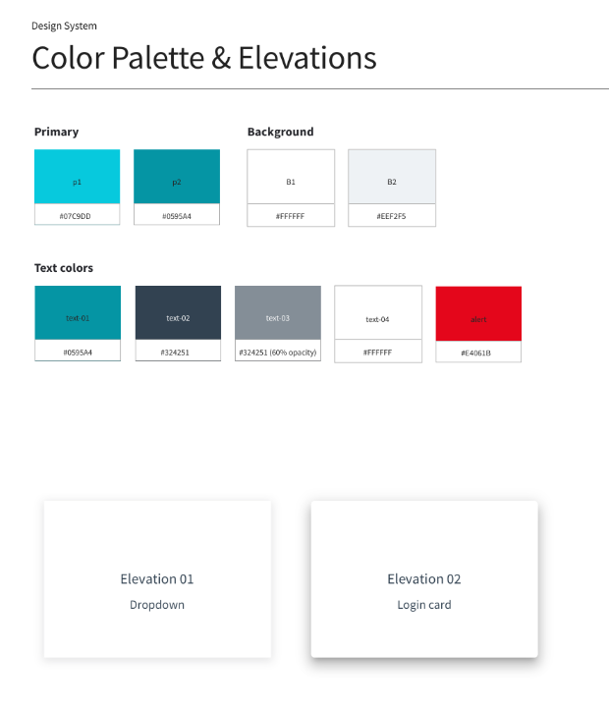

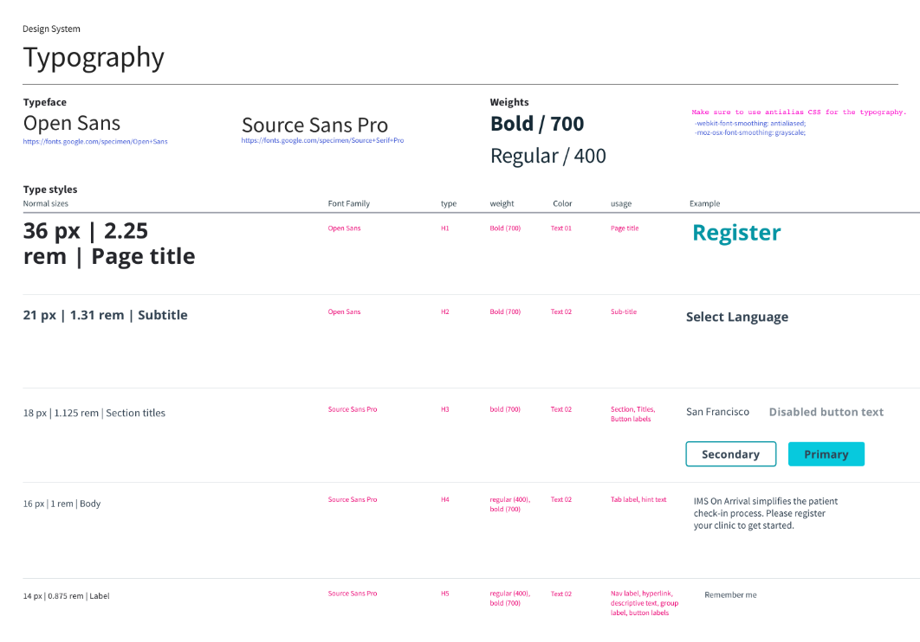

**WEEKLY REPORT 12**

This week, I made a design document for the rest of the screen which I designed so that developers can start work on that via coding.

The goal was to learn better user experience for creating design and also design documents for that.

To confirm that our design complies with these criteria, I also looked into the IMS and HIPAA regulations.

https://99designs.com/inspiration/designs/document

